**Functional Dependencies and Anomalies**

In this document, we will dissect the functional dependencies and find anomalies from the result of our ER diagram in Figure 1 below.

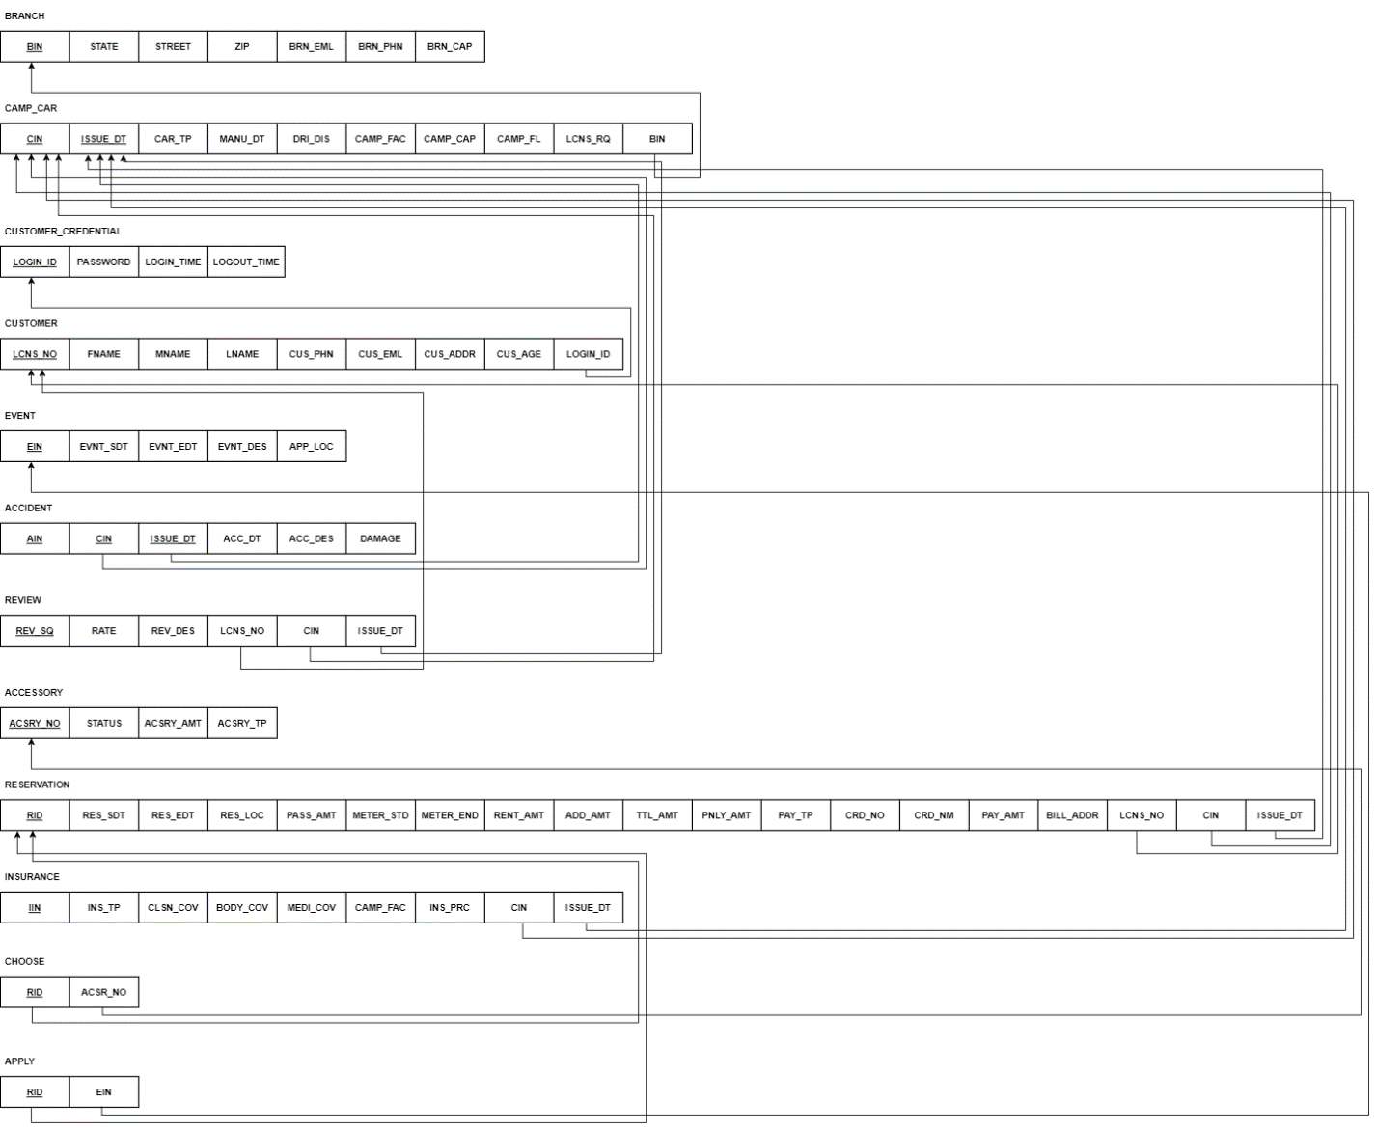

Figure

1. **Functional dependencies**

From the attributes, we will identify the functional dependencies to verify the primary key in our ER diagram.

1. **Branch**

Branch ID -> branch state, branch street, branch zip code, branch email, branch phone, branch capacity

1. **Camping car**

Camping car ID -> issue date, car type, manufacture date, distance driven, facilities, passenger, availability, required license, branch ID

1. **Customer credentials**

Login ID -> password, login time, logout time

1. **Customer name**

License number -> First name, middle name, last name, phone number, email, address, age, login ID

1. **Event**

Event ID -> Event start date, event end date, event description, event applied location

1. **Accident**

Accident ID -> Camping car ID, issue date, accident date, accident description, damage

1. **Review**



Review ID -> rate of service, review description, camping car reviewed

1. **Accessory**

Accessory ID -> accessory status, accessory amount, accessory type

1. **Reservation**

Reservation ID -> reservation start date, reservation end date, reservation start location, passenger number, meter start, meter end, rental amount, additional amount, total amount, penalty amount, payment type, card number, card name, pay amount, billing address, license number, camping car ID, issue date.

1. **Insurance**

Insurance ID -> insurance type, collision coverage, body coverage, medical coverage, camping car facilities, insurance price, camping car ID, issue date.

1. **Choose**

Reservation ID -> accessory number

1. **Apply**

Reservation ID -> Event ID

1. **Anomalies**

From here, we can analyze and anomalies we might have in our structure. There are two types of anomalies in this structure.

1. Expected insertion anomalies
2. Camping car: distance driven.
3. Customer credential: login time and logout time.
4. Reservation: Meter end, penalty amount, pay amount.

These attributes should be updated after the service has been used. Data for these attributes may not be available, and we will keep that in mind when building our database.

1. Insertion anomalies that need to be resolved
2. In case of payment type being other than card, card number, card name, and billing address will not be available.
3. **Resolution**

To resolve the payment section in the reservation table, we will create a **Pay** table and **Pay Type** table. After separating the attributes related to the pay and pay type table, from the reservation table, reservation table will have Pay ID as foreign key, that is related to the Pay table, and then in the Pay table we have the Pay type as foreign key which is related to the Pay Type table.

1. **Final form**

